JAVA PROGRAMMING
DIGITAL ASSIGNMENT 1 & 2
SWATI SINGH
18BCE1018

HOUSE RENTING SYSTEM

Finding a house for rent or finding a tenant for your house is a very difficult task nowadays. A lot of hustle is required. To ease the process of getting a house on rent, this application will allow people to search for all the houses available on Rent. Interested landlords can also put their house on rent. The landlords can check who has purchased their listed house.

The application is developed using JavaFX and FXML feature.
MySQL database is used for backend.

Basic Structure:-
Main.java

Register Login

Main Page

Put on Rent Rent House View Rented House My Profile SignOut

Registration Page:-
- Any new visitor will first have to register himself on the application by providing his details.

Code:-
Register.fxml==>
<?xml version="1.0" encoding="UTF-8"?>

<?import javafx.scene.control.Button?>
<?import javafx.scene.control.DatePicker?>
<?import javafx.scene.control.Label?>
<?import javafx.scene.control.PasswordField?>
<?import javafx.scene.control.Separator?>
<?import javafx.scene.control.TextField?>
<?import javafx.scene.layout.AnchorPane?>
<?import javafx.scene.layout.BorderPane?>
<?import javafx.scene.text.Font?>

<AnchorPane id="AnchorPane" fx:id="regPane" maxHeight="-Infinity" maxWidth="-Infinity" minHeight="-Infinity" minWidth="-Infinity" prefHeight="649.0" prefWidth="900.0" xmlns="http://javafx.com/javafx/11.0.1" xmlns:fx="http://javafx.com/fxml/1" fx:controller="Rental.RegisterController">
<children>
<BorderPane layoutX="12.0" layoutY="14.0" prefHeight="141.0" prefWidth="878.0">
<center>
<Label alignment="CENTER" contentDisplay="CENTER" prefHeight="119.0" prefWidth="855.0" text="HOUSE RENTING SYSTEM" BorderPane.alignment="CENTER">
<font>
<Font name="Bookman Old Style Bold Italic" size="37.0" />
</font>
</Label>
</center>
</BorderPane>
<Separator layoutX="348.0" layoutY="183.0" prefWidth="202.0" />
<Label alignment="CENTER" layoutX="243.0" layoutY="147.0" prefHeight="17.0" prefWidth="413.0" text="REGISTER">
<font>
<Font name="Bookman Old Style Bold" size="24.0" />
</font>
</Label>
<TextField fx:id="tf1" layoutX="243.0" layoutY="196.0" promptText="Name">
<font>
<Font name="System Italic" size="14.0" />
</font>
</TextField>
<DatePicker fx:id="dob" layoutX="463.0" layoutY="199.0" promptText="Date-Of-Birth" />
<TextField fx:id="tf2" layoutX="243.0" layoutY="246.0" promptText="E-mail">
<font>
<Font name="System Italic" size="14.0" />
</font>
</TextField>
<TextField fx:id="tf3" layoutX="463.0" layoutY="246.0" promptText="Phone No.">
<font>
<Font name="System Italic" size="14.0" />
</font>
</TextField>
<Label layoutX="243.0" layoutY="290.0" prefHeight="17.0" prefWidth="97.0" text="Address:">
<font>
<Font name="Arial Italic" size="17.0" />
</font>
</Label>
<TextField fx:id="tf4" layoutX="242.0" layoutY="319.0" promptText="House No.">
<font>
<Font size="14.0" />
</font>
</TextField>
<TextField fx:id="tf5" layoutX="462.0" layoutY="319.0" promptText="Locality">
<font>
<Font size="14.0" />
</font>
</TextField>
<TextField fx:id="tf6" layoutX="242.0" layoutY="356.0" promptText="Street">
<font>
<Font size="14.0" />
</font>
</TextField>
<TextField fx:id="tf7" layoutX="462.0" layoutY="356.0" promptText="City">
<font>
<Font size="14.0" />
</font>
</TextField>
<TextField fx:id="tf8" layoutX="242.0" layoutY="391.0" promptText="State">
<font>
<Font size="14.0" />
</font>
</TextField>
<TextField fx:id="tf9" layoutX="462.0" layoutY="391.0" promptText="Pin Code">
<font>
<Font size="14.0" />
</font>
</TextField>
<Label layoutX="242.0" layoutY="427.0" prefHeight="17.0" prefWidth="159.0" text="Aadhaar Number:">
<font>
<Font name="Arial Italic" size="16.0" />
</font>
</Label>
<TextField fx:id="tf10" layoutX="242.0" layoutY="450.0">
<font>
<Font size="14.0" />
</font>
</TextField>
<Button fx:id="btn1" layoutX="414.0" layoutY="565.0" mnemonicParsing="false" onAction="#OnRegister" text="Register">
<font>
<Font size="14.0" />
</font>
</Button>
<Label layoutX="462.0" layoutY="427.0" prefHeight="18.0" prefWidth="174.0" text="Pan Card Number:">
<font>
<Font name="Arial Italic" size="17.0" />
</font>
</Label>
<TextField fx:id="tf11" layoutX="462.0" layoutY="450.0">
<font>
<Font size="14.0" />
</font>
</TextField>
<Label layoutX="242.0" layoutY="488.0" prefHeight="18.0" prefWidth="159.0" text="Password:">
<font>
<Font name="Arial Italic" size="16.0" />
</font>
</Label>
<Label layoutX="462.0" layoutY="488.0" prefHeight="18.0" prefWidth="159.0" text="Re-enter Password:">
<font>
<Font name="Arial Italic" size="16.0" />
</font>
</Label>
<PasswordField fx:id="tf12" layoutX="242.0" layoutY="510.0">
<font>
<Font size="14.0" />
</font>
</PasswordField>
<PasswordField fx:id="tf13" layoutX="462.0" layoutY="510.0">
<font>
<Font size="14.0" />
</font>
</PasswordField>
<Label fx:id="lb1" layoutX="649.0" layoutY="515.0" prefHeight="18.0" prefWidth="220.0" textFill="#d21c1c">
<font>
<Font name="System Italic" size="14.0" />
</font>
</Label>
<Button fx:id="btn2" layoutX="420.0" layoutY="605.0" mnemonicParsing="false" onAction="#LoginAgain" text="Login">
<font>
<Font size="15.0" />
</font>
</Button>
</children>
</AnchorPane>

RegisterController.java==>
/*
* To change this license header, choose License Headers in Project Properties.
* To change this template file, choose Tools | Templates
* and open the template in the editor.
*/
package Rental;

import com.mysql.jdbc.Connection;
import com.mysql.jdbc.PreparedStatement;
import java.io.IOException;
import java.net.URL;
import java.sql.DriverManager;
import java.sql.*;
import java.time.LocalDate;
import java.util.ResourceBundle;
import java.util.logging.Level;
import java.util.logging.Logger;
import javafx.event.ActionEvent;
import javafx.fxml.*;
import javafx.scene.*;
import javafx.scene.control.*;
import javafx.scene.layout.AnchorPane;

/**
* FXML Controller class
*
* @author Swati
*/
public class RegisterController implements Initializable {

/**
* Initializes the controller class.
*/
@Override
public void initialize(URL url, ResourceBundle rb) {
// TODO
}
@FXML
private AnchorPane regPane;
@FXML
private TextField tf1;
@FXML
private TextField tf2;
@FXML
private TextField tf3;
@FXML
private TextField tf4;
@FXML
private TextField tf5;
@FXML
private TextField tf6;
@FXML
private TextField tf7;
@FXML
private TextField tf8;
@FXML
private TextField tf9;
@FXML
private TextField tf10;
@FXML
private Button btn1;
@FXML
private DatePicker dob;
@FXML
private TextField tf11;
@FXML
private PasswordField tf12;
@FXML
private PasswordField tf13;
@FXML
private Label lb1;
@FXML
private Button btn2;

Connection conn;
PreparedStatement pst;
PreparedStatement pst1;
ResultSet rs;
public void OnRegister(ActionEvent event)throws IOException, SQLException{
String name = tf1.getText();
String email = tf2.getText();
String phone = tf3.getText();
String house = tf4.getText();
String locality = tf5.getText();
String street = tf6.getText();
String city = tf7.getText();
String state = tf8.getText();
String pin = tf9.getText();
String aadhar=tf10.getText();
String pan = tf11.getText();
LocalDate date = dob.getValue();
java.sql.Date sqld = java.sql.Date.valueOf(date);
String pass1 = tf12.getText();
String pass2 = tf13.getText();
if(pass1.equals(pass2)==false){
lb1.setText("Password don't match");
}
else{
try{
Class.forName("com.mysql.jdbc.Driver");
conn = (Connection) DriverManager.getConnection("jdbc:mysql://localhost:3308/houserentalsystem","root","12345");
pst = (PreparedStatement) conn.prepareStatement("Insert into register (name,datebirth,email,phone,house,locality,street,city,state,pincode,aadhar,pan,pass)"+"values(?,?,?,?,?,?,?,?,?,?,?,?,?)");
pst.setString(1,name);
pst.setDate(2,sqld);
pst.setString(3,email);
pst.setString(4, phone);
pst.setString(5,house);
pst.setString(6,locality);
pst.setString(7,street);
pst.setString(8, city);
pst.setString(9, state);
pst.setString(10,pin);
pst.setString(11,aadhar);
pst.setString(12,pan);
pst.setString(13,pass1);

pst.execute();

pst1 = (PreparedStatement) conn.prepareStatement("Insert into user_login (username,password)"+"values(?,?)");
pst1.setString(1,email);
pst1.setString(2,pass1);

pst1.execute();

Parent root1 = FXMLLoader.load(getClass().getResource("/Rental/Reg_Success.fxml"));
regPane.getChildren().setAll(root1);
} catch (ClassNotFoundException ex) {
Logger.getLogger(LoginController.class.getName()).log(Level.SEVERE, null, ex);
}
}
}
public void LoginAgain(ActionEvent event) throws IOException{
Parent root1 = FXMLLoader.load(getClass().getResource("/Rental/Login.fxml"));
regPane.getChildren().setAll(root1);
}
}

Interface:-
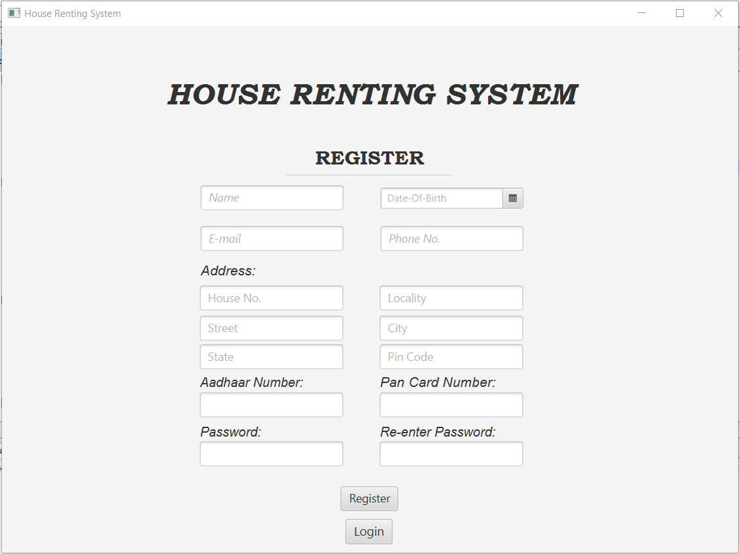
Database==>
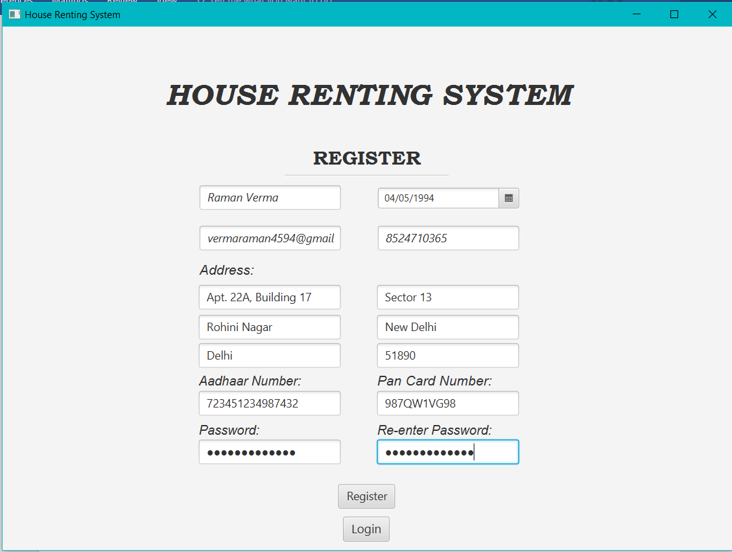
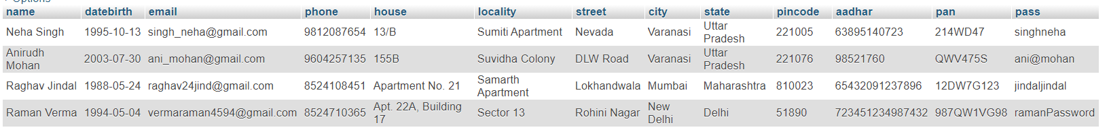
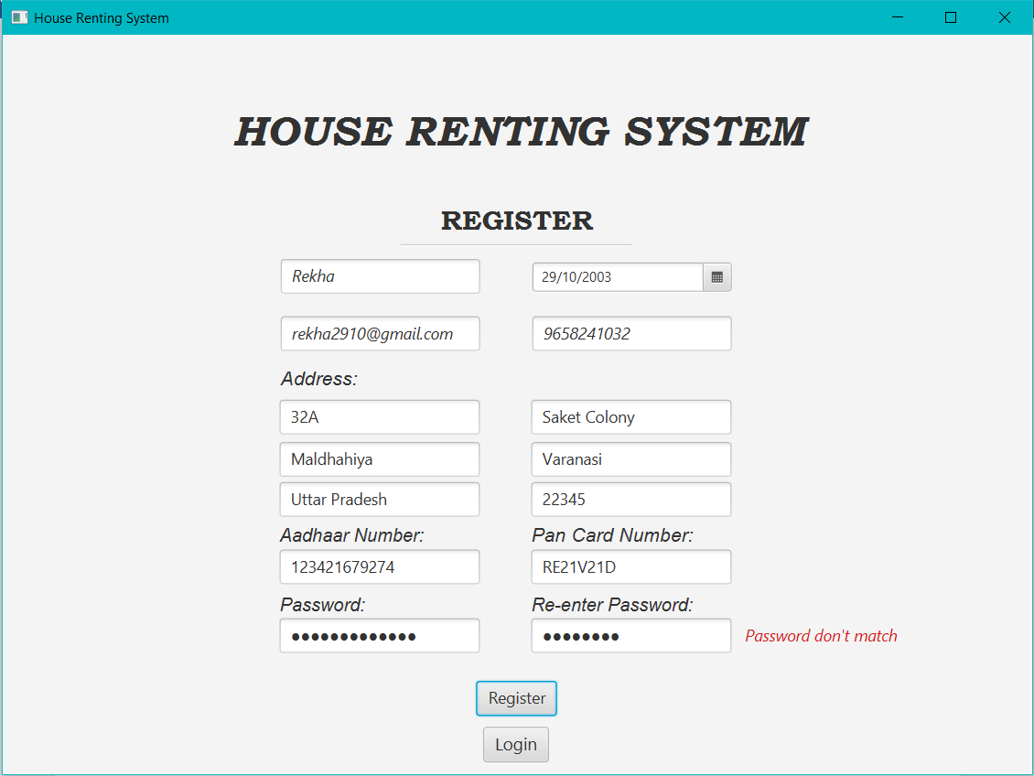

Registration Success Page:-
Code:-
Reg_success.fxml==>
<?xml version="1.0" encoding="UTF-8"?>

<?import javafx.scene.control.Button?>
<?import javafx.scene.control.Label?>
<?import javafx.scene.layout.AnchorPane?>
<?import javafx.scene.layout.BorderPane?>
<?import javafx.scene.text.Font?>

<AnchorPane id="AnchorPane" fx:id="successPane" prefHeight="600.0" prefWidth="900.0" xmlns="http://javafx.com/javafx/11.0.1" xmlns:fx="http://javafx.com/fxml/1" fx:controller="Rental.Reg_SuccessController">
<children>
<BorderPane layoutX="8.0" layoutY="14.0" prefHeight="114.0" prefWidth="884.0">
<center>
<Label alignment="CENTER" prefHeight="106.0" prefWidth="858.0" text="HOUSE RENTING SYSTEM" BorderPane.alignment="CENTER">
<font>
<Font name="Bookman Old Style Bold Italic" size="37.0" />
</font>
</Label>
</center>
</BorderPane>
<Label alignment="CENTER" layoutX="250.0" layoutY="203.0" prefHeight="27.0" prefWidth="398.0" text="You are successfully registered" textFill="#e23939">
<font>
<Font name="Arial Black" size="18.0" />
</font>
</Label>
<Button fx:id="btn1" alignment="CENTER" contentDisplay="CENTER" layoutX="363.0" layoutY="300.0" mnemonicParsing="false" onAction="#Reg_Log" prefHeight="38.0" prefWidth="174.0" style="-fx-background-color: #1603FB;" text="Click Here to Login" textFill="#f2eeee">
<font>
<Font name="System Bold Italic" size="15.0" />
</font>
</Button>
<Label alignment="CENTER" contentDisplay="CENTER" layoutX="258.0" layoutY="243.0" prefHeight="27.0" prefWidth="384.0" text="Please use your email-id to Login" textFill="#e23939">
<font>
<Font name="Arial Black" size="18.0" />
</font>
</Label>
</children>
</AnchorPane>

Reg_SuccessController==>
/*
* To change this license header, choose License Headers in Project Properties.
* To change this template file, choose Tools | Templates
* and open the template in the editor.
*/
package Rental;

import java.io.IOException;
import java.net.URL;
import java.util.ResourceBundle;
import javafx.event.ActionEvent;
import javafx.fxml.FXML;
import javafx.fxml.FXMLLoader;
import javafx.fxml.Initializable;
import javafx.scene.Parent;
import javafx.scene.control.Button;
import javafx.scene.layout.AnchorPane;

/**
* FXML Controller class
*
* @author Swati
*/
public class Reg_SuccessController implements Initializable {

/**
* Initializes the controller class.
*/
@FXML
private AnchorPane successPane;
@FXML
private Button btn1;
@Override
public void initialize(URL url, ResourceBundle rb) {
// TODO
}
public void Reg_Log(ActionEvent event) throws IOException{
//Stage stage1 = new Stage();
Parent root1 = FXMLLoader.load(getClass().getResource("/Rental/Login.fxml"));
successPane.getChildren().setAll(root1);
}
}

Interface:-
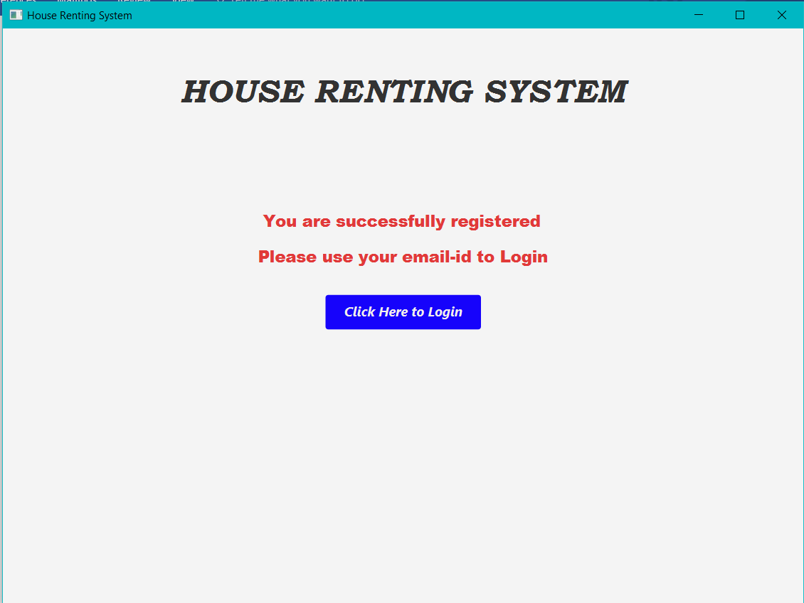

Login Page:-
After successful registration, the user can use the login page to visit the page.
Users email-id and the chosen password is saved in the ‘users’ table which is retrieved for login.

Code:-
Login.fxml==>
<?xml version="1.0" encoding="UTF-8"?>

<?import javafx.geometry.Insets?>
<?import javafx.scene.control.Button?>
<?import javafx.scene.control.Label?>
<?import javafx.scene.control.PasswordField?>
<?import javafx.scene.control.Separator?>
<?import javafx.scene.control.TextField?>
<?import javafx.scene.layout.AnchorPane?>
<?import javafx.scene.layout.BorderPane?>
<?import javafx.scene.layout.Pane?>
<?import javafx.scene.text.Font?>

<AnchorPane id="AnchorPane" fx:id="LoginPane" prefHeight="646.0" prefWidth="900.0" styleClass="mainFxmlClass" xmlns="http://javafx.com/javafx/11.0.1" xmlns:fx="http://javafx.com/fxml/1" fx:controller="Rental.LoginController">
<children>
<BorderPane layoutX="13.0" layoutY="14.0" prefHeight="134.0" prefWidth="874.0">
<center>
<Label alignment="CENTER" contentDisplay="CENTER" prefHeight="90.0" prefWidth="813.0" text="HOUSE RENTING SYSTEM" BorderPane.alignment="CENTER">
<font>
<Font name="Bookman Old Style Bold Italic" size="37.0" />
</font>
</Label>
</center>
</BorderPane>
<Pane layoutX="283.0" layoutY="193.0" prefHeight="384.0" prefWidth="334.0" styleClass="mainFxmlClass">
<children>
<PasswordField fx:id="tf3" alignment="CENTER" layoutX="48.0" layoutY="151.0" prefHeight="36.0" prefWidth="239.0" promptText="Password">
<font>
<Font name="Arial Italic" size="18.0" />
</font>
</PasswordField>
<TextField fx:id="tf2" alignment="CENTER" layoutX="49.0" layoutY="100.0" promptText="Username">
<font>
<Font name="Arial Italic" size="19.0" />
</font>
</TextField>
<Button fx:id="btn1" alignment="CENTER" layoutX="136.0" layoutY="212.0" mnemonicParsing="false" onAction="#Login" text="Login" textAlignment="CENTER">
<font>
<Font name="Arial" size="17.0" />
</font>
</Button>
<Button fx:id="btn2" layoutX="125.0" layoutY="258.0" mnemonicParsing="false" onAction="#Register" text="Register">
<font>
<Font name="Arial" size="17.0" />
</font>
</Button>
<Separator layoutX="69.0" layoutY="66.0" prefWidth="200.0" />
<Label alignment="CENTER" contentDisplay="CENTER" layoutX="24.0" layoutY="23.0" prefHeight="43.0" prefWidth="287.0" text="LOGIN">
<font>
<Font name="Bookman Old Style Bold" size="24.0" />
</font>
</Label>
<Label fx:id="lbl1" alignment="CENTER" contentDisplay="CENTER" layoutX="47.0" layoutY="303.0" prefHeight="17.0" prefWidth="239.0" textFill="#fd0202">
<font>
<Font name="Bodoni MT Italic" size="14.0" />
</font>
</Label>
<Label fx:id="lbl2" alignment="CENTER" contentDisplay="CENTER" layoutX="21.0" layoutY="336.0" prefHeight="17.0" prefWidth="287.0" textFill="#fa0505">
<font>
<Font name="Bodoni MT Italic" size="14.0" />
</font>
</Label>
</children>
<opaqueInsets>
<Insets bottom="10.0" left="10.0" right="10.0" top="10.0" />
</opaqueInsets>
</Pane>
</children>
</AnchorPane>

LoginController.java==>
/*
* To change this license header, choose License Headers in Project Properties.
* To change this template file, choose Tools | Templates
* and open the template in the editor.
*/
package Rental;

import com.mysql.jdbc.Connection;
import com.mysql.jdbc.PreparedStatement;
import java.sql.DriverManager;
import java.sql.ResultSet;
import java.io.IOException;
import java.net.URL;
import java.sql.SQLException;
import java.util.ResourceBundle;
import java.util.logging.Level;
import java.util.logging.Logger;
import javafx.event.ActionEvent;
import javafx.fxml.*;
import javafx.scene.Parent;
import javafx.scene.control.*;
import javafx.scene.layout.AnchorPane;

/**
* FXML Controller class
*
* @author Swati
*/
public class LoginController implements Initializable {

/**
* Initializes the controller class.
* @param url
* @param rb
*/
@Override
public void initialize(URL url, ResourceBundle rb) {
// TODO
}
@FXML
private AnchorPane LoginPane;
@FXML
private TextField tf2;
@FXML
private PasswordField tf3;
@FXML
private Button btn1;
@FXML
private Button btn2;
@FXML
private Label lbl1;
@FXML
private Label lbl2;
Connection conn;
PreparedStatement pst;
PreparedStatement pst1;
ResultSet rs;
ResultSet rs1;

public void Register(ActionEvent event) throws IOException{
Parent root = FXMLLoader.load(getClass().getResource("/Rental/Register.fxml"));
LoginPane.getChildren().setAll(root);
}

public void Login(ActionEvent event) throws IOException, SQLException{
String uname=tf2.getText();
String pass = tf3.getText();
try{
Class.forName("com.mysql.jdbc.Driver");
conn = (Connection) DriverManager.getConnection("jdbc:mysql://localhost:3308/houserentalsystem","root","12345");
pst = (PreparedStatement) conn.prepareStatement("Select * from user_login where username=? and password=?");
pst.setString(1,uname);
pst.setString(2,pass);

rs = pst.executeQuery();
if(rs.next()){
//Stage stage1 = new Stage();
pst1 = (PreparedStatement) conn.prepareStatement("Select * from register where email=?");
pst1.setString(1,uname);
//pst1.setString(2,pass);

rs1 = pst1.executeQuery();
if(rs1.next()){
FXMLLoader loader = new FXMLLoader();
Parent root1 = loader.load(getClass().getResource("/Rental/MainPage.fxml").openStream());
MainPageController u = (MainPageController)loader.getController();
u.getUser(rs1.getString("name"));
LoginPane.getChildren().setAll(root1);
}
}
else{
tf2.clear();
tf3.clear();
lbl1.setText("Incorrect Username or Password!");
lbl2.setText("Please Register if you don't have an account");
}
} catch (ClassNotFoundException ex) {
Logger.getLogger(LoginController.class.getName()).log(Level.SEVERE, null, ex);
}
}
}
Database:-
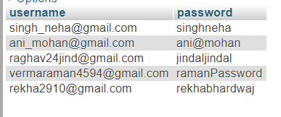
Interface:-
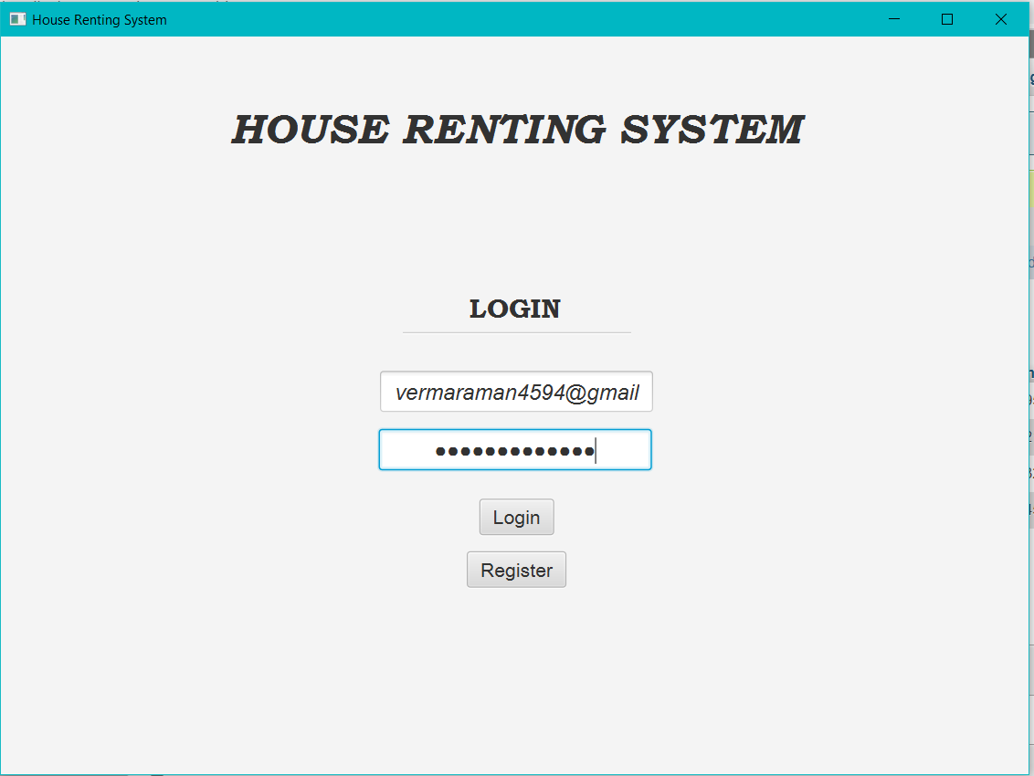
On inputing wrong password, an error message appears or else the user is redirected to the main page.
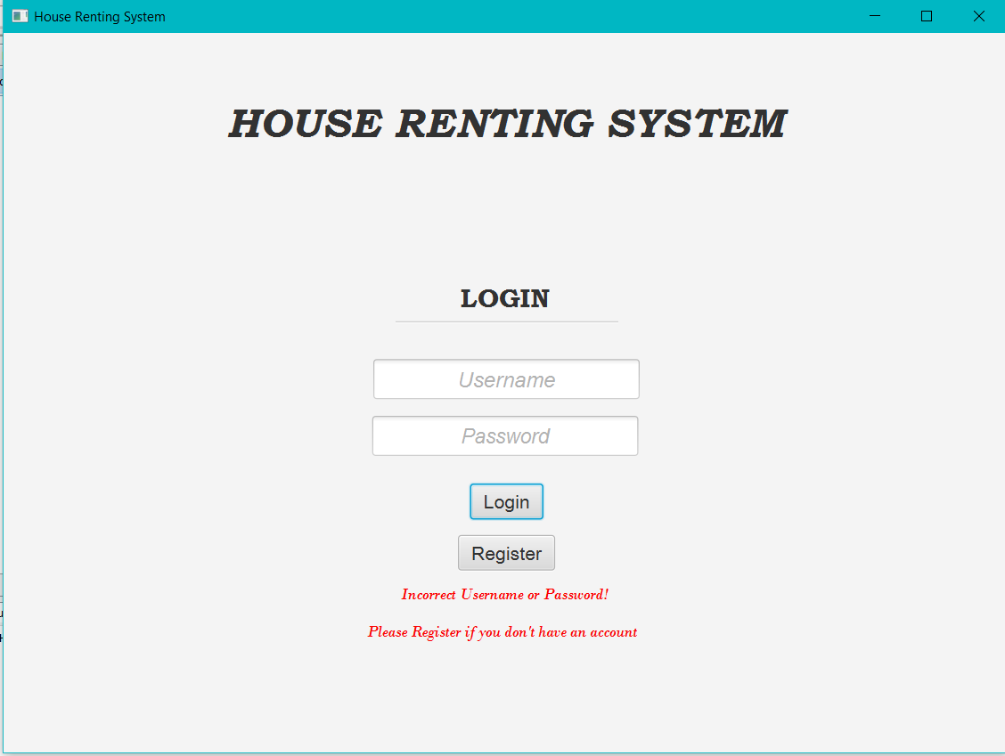
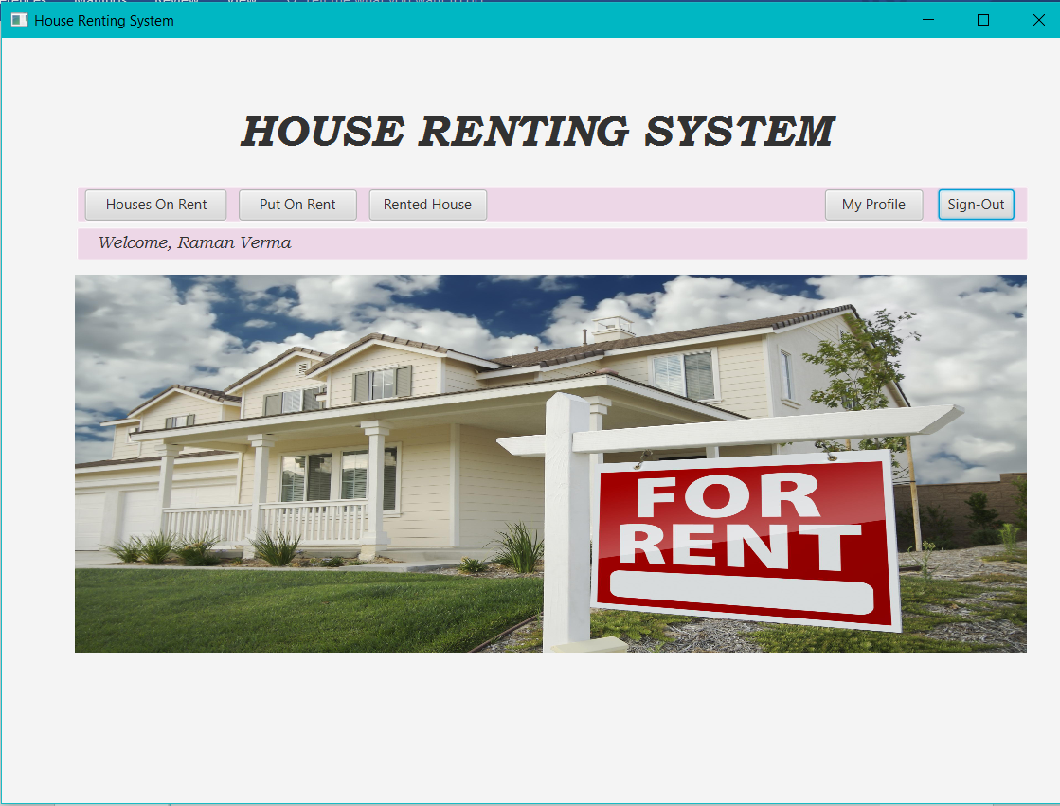
Main Page:-
Main page appears after successful login and displays the users name on the front page.
This main page has various functionalities as implemented by the buttons.
Code:-
MainPage.fxml==>
<?xml version="1.0" encoding="UTF-8"?>

<?import javafx.scene.control.Button?>
<?import javafx.scene.control.Label?>
<?import javafx.scene.image.ImageView?>
<?import javafx.scene.layout.AnchorPane?>
<?import javafx.scene.layout.BorderPane?>
<?import javafx.scene.shape.Rectangle?>
<?import javafx.scene.text.Font?>
<?import javafx.scene.image.Image?>

<AnchorPane id="AnchorPane" fx:id="mainPane" prefHeight="600.0" prefWidth="900.0" xmlns="http://javafx.com/javafx/11.0.1" xmlns:fx="http://javafx.com/fxml/1" fx:controller="Rental.MainPageController">
<children>
<BorderPane layoutX="8.0" layoutY="14.0" prefHeight="130.0" prefWidth="884.0">
<center>
<Label alignment="CENTER" prefHeight="114.0" prefWidth="862.0" text="HOUSE RENTING SYSTEM" BorderPane.alignment="CENTER">
<font>
<Font name="Bookman Old Style Bold Italic" size="37.0" />
</font>
</Label>
</center>
</BorderPane>
<Rectangle arcHeight="5.0" arcWidth="5.0" fill="#edd7e7" height="31.0" layoutX="63.0" layoutY="125.0" stroke="#fdfcfc" strokeType="INSIDE" width="804.0" />
<Button fx:id="btn4" layoutX="791.0" layoutY="128.0" mnemonicParsing="false" onAction="#signOut" text="Sign-Out" />
<Button fx:id="btn1" layoutX="70.0" layoutY="128.0" mnemonicParsing="false" prefHeight="26.0" prefWidth="120.0" onAction="#Buy" text="Houses On Rent" />
<Button fx:id="btn2" layoutX="200.0" layoutY="128.0" mnemonicParsing="false" prefHeight="26.0" prefWidth="100.0" onAction="#sell" text="Put On Rent" />
<Button fx:id="btn5" layoutX="310.0" layoutY="128.0" mnemonicParsing="false" prefHeight="26.0" prefWidth="100.0" onAction="#view" text="Rented House" />
<Button fx:id="btn3" layoutX="695.0" layoutY="128.0" mnemonicParsing="false" prefHeight="26.0" prefWidth="83.0" onAction="#profile" text="My Profile" />
<Rectangle arcHeight="5.0" arcWidth="5.0" fill="#edd7e7" height="28.0" layoutX="63.0" layoutY="160.0" stroke="#fdfcfc" strokeType="INSIDE" width="804.0" />
<Label fx:id="lbl2" prefHeight="26.0" prefWidth="862.0" layoutX="80.0" layoutY="160.0" text="Hi" >
<font>
<Font name="Bookman Old Style Italic" size="14.0" />
</font>
</Label>
<ImageView fx:id="imagerent" fitHeight="319.0" fitWidth="804.0" layoutX="62.0" layoutY="200.0" pickOnBounds="true" >
<image>
<Image url="images/im1.jpg"></Image>
</image>
</ImageView>
</children>
</AnchorPane>

MainPageController.java==>
/*
* To change this license header, choose License Headers in Project Properties.
* To change this template file, choose Tools | Templates
* and open the template in the editor.
*/
package Rental;

import java.io.IOException;
import java.net.URL;
import java.sql.SQLException;
import java.util.ResourceBundle;
import javafx.event.ActionEvent;
import javafx.fxml.FXML;
import javafx.fxml.FXMLLoader;
import javafx.fxml.Initializable;
import javafx.scene.Parent;
import javafx.scene.Scene;
import javafx.scene.control.Button;
import javafx.scene.control.Label;
import javafx.scene.image.ImageView;
import javafx.scene.layout.AnchorPane;
import javafx.stage.Stage;

/**
* FXML Controller class
*
* @author Swati
*/
public class MainPageController implements Initializable {

/**
* Initializes the controller class.
*/
@FXML
private AnchorPane mainPane;
@FXML
private Button btn1;

@FXML
private Button btn2;

@FXML
private Button btn3;

@FXML
private Button btn4;

@FXML
private ImageView imagerent;
@FXML
private Label lbl2;
String username;
@Override
public void initialize(URL url, ResourceBundle rb) {

}
public void getUser(String user){
username=user;
lbl2.setText("Welcome, "+user);
}
public void Buy(ActionEvent event) throws IOException{
FXMLLoader loader = new FXMLLoader();
Parent root1 = loader.load(getClass().getResource("/Rental/Purchase.fxml").openStream());
PurchaseController u = (PurchaseController)loader.getController();
u.getUser(username);
mainPane.getChildren().setAll(root1);
/*
Scene scene = new Scene(root);
Stage stage = new Stage();
stage.setScene(scene);
stage.setTitle("House Rental Management System");
stage.show();
*/
}
public void sell(ActionEvent event) throws IOException{
FXMLLoader loader = new FXMLLoader();
Parent root1 = loader.load(getClass().getResource("/Rental/Sell.fxml").openStream());
SellController s = (SellController)loader.getController();
s.getUser(username);
mainPane.getChildren().setAll(root1);
}

public void view(ActionEvent event) throws IOException{
FXMLLoader loader = new FXMLLoader();
Parent root1 = loader.load(getClass().getResource("/Rental/View.fxml").openStream());
ViewController s = (ViewController)loader.getController();
s.getUser(username);
mainPane.getChildren().setAll(root1);
}
public void signOut(ActionEvent event) throws IOException{
Parent root = FXMLLoader.load(getClass().getResource("/Rental/SignOut.fxml"));
mainPane.getChildren().setAll(root);
}
public void profile(ActionEvent event) throws IOException, SQLException{
FXMLLoader loader = new FXMLLoader();
Parent root1 = loader.load(getClass().getResource("/Rental/MyProfile.fxml").openStream());
MyProfileController s = (MyProfileController)loader.getController();
s.MyProfileController(username);
mainPane.getChildren().setAll(root1);
}
}

Interface:-
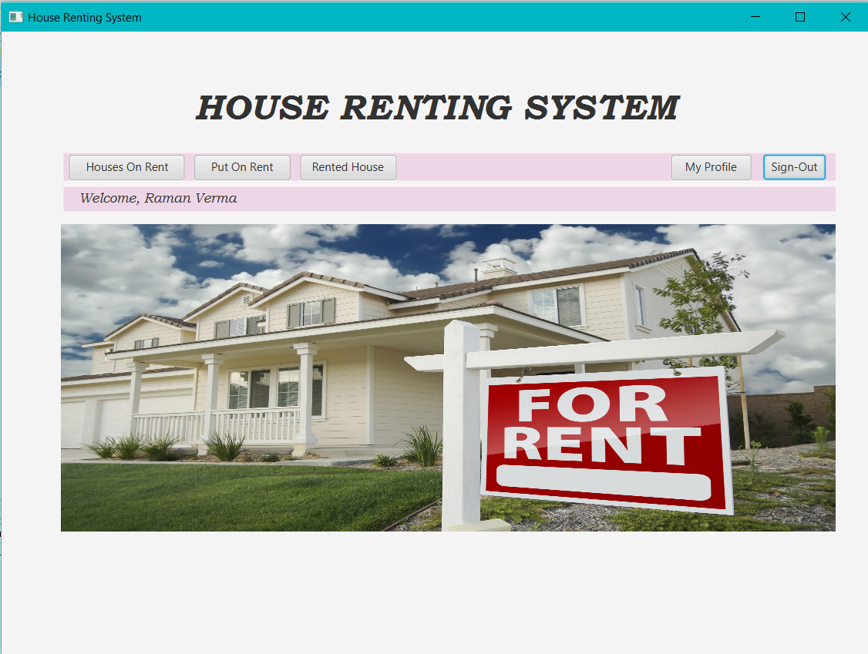

Put Houses on Rent:-
This button let’s a landlord enter all the required details of his house in order to list it on rent.
Code:-
Sell.fxml==>
<?xml version="1.0" encoding="UTF-8"?>

<?import javafx.scene.control.Button?>
<?import javafx.scene.control.Label?>
<?import javafx.scene.control.Separator?>
<?import javafx.scene.control.TextArea?>
<?import javafx.scene.control.TextField?>
<?import javafx.scene.layout.AnchorPane?>
<?import javafx.scene.layout.BorderPane?>
<?import javafx.scene.text.Font?>

<AnchorPane id="AnchorPane" fx:id="sellPane" prefHeight="600.0" prefWidth="900.0" xmlns="http://javafx.com/javafx/11.0.1" xmlns:fx="http://javafx.com/fxml/1" fx:controller="Rental.SellController">
<children>
<BorderPane layoutX="11.0" layoutY="14.0" prefHeight="119.0" prefWidth="879.0">
<center>
<Label alignment="CENTER" prefHeight="114.0" prefWidth="866.0" text="HOUSE RENTING SYSTEM" BorderPane.alignment="CENTER">
<font>
<Font name="Bookman Old Style Bold Italic" size="37.0" />
</font>
</Label>
</center>
</BorderPane>
<Separator layoutX="23.0" layoutY="146.0" prefHeight="3.0" prefWidth="854.0" />
<Label alignment="CENTER" layoutX="350.0" layoutY="119.0" prefHeight="27.0" prefWidth="201.0" text="HOUSE DETAILS">
<font>
<Font name="Baskerville Old Face" size="23.0" />
</font>
</Label>
<TextField fx:id="tf1" layoutX="363.0" layoutY="161.0" promptText="Enter Location">
<font>
<Font name="System Italic" size="14.0" />
</font>
</TextField>
<TextField fx:id="tf2" layoutX="363.0" layoutY="203.0" promptText="Dimensions">
<font>
<Font name="System Italic" size="14.0" />
</font>
</TextField>
<Label layoutX="552.0" layoutY="210.0" prefHeight="16.0" prefWidth="56.0" text="Sq. Feet">
<font>
<Font name="Arial Italic" size="13.0" />
</font>
</Label>
<TextField fx:id="tf3" layoutX="363.0" layoutY="248.0" promptText="No. of Rooms">
<font>
<Font name="System Italic" size="14.0" />
</font>
</TextField>
<TextField fx:id="tf4" layoutX="363.0" layoutY="294.0" promptText="No. of Bathrooms">
<font>
<Font name="System Italic" size="14.0" />
</font>
</TextField>
<TextArea fx:id="tf5" layoutX="363.0" layoutY="336.0" prefHeight="90.0" prefWidth="174.0" promptText="Description">
<font>
<Font name="System Italic" size="14.0" />
</font>
</TextArea>
<TextField fx:id="tf6" layoutX="363.0" layoutY="438.0" promptText="Rent/Month">
<font>
<Font name="System Italic" size="14.0" />
</font>
</TextField>
<Label layoutX="552.0" layoutY="445.0" text="Rupees/Month">
<font>
<Font name="Arial Italic" size="13.0" />
</font>
</Label>
<Button fx:id="btn1" layoutX="393.0" layoutY="498.0" mnemonicParsing="false" onAction="#toList" text="List For Rent">
<font>
<Font name="Bodoni MT" size="16.0" />
</font>
</Button>
<Button fx:id="btn2" layoutX="424.0" layoutY="544.0" mnemonicParsing="false" onAction="#Back" text="Back">
<font>
<Font name="Bodoni MT" size="15.0" />
</font>
</Button>
</children>
</AnchorPane>

SellController.java==>
/*
* To change this license header, choose License Headers in Project Properties.
* To change this template file, choose Tools | Templates
* and open the template in the editor.
*/
package Rental;

import com.mysql.jdbc.Connection;
import com.mysql.jdbc.PreparedStatement;
import java.io.IOException;
import java.net.URL;
import java.sql.DriverManager;
import java.sql.ResultSet;
import java.sql.SQLException;
import java.util.ResourceBundle;
import java.util.logging.Level;
import java.util.logging.Logger;
import javafx.event.ActionEvent;
import javafx.fxml.FXML;
import javafx.fxml.FXMLLoader;
import javafx.fxml.Initializable;
import javafx.scene.Parent;
import javafx.scene.control.Button;
import javafx.scene.control.TextArea;
import javafx.scene.control.TextField;
import javafx.scene.layout.AnchorPane;

/**
* FXML Controller class
*
* @author Swati
*/
public class SellController implements Initializable {

/**
* Initializes the controller class.
*/
@FXML
private TextField tf1;
@FXML
private TextField tf2;
@FXML
private TextField tf3;
@FXML
private TextField tf4;
@FXML
private TextArea tf5;
@FXML
private TextField tf6;
@FXML
private Button btn1;
@FXML
private AnchorPane sellPane;
@FXML
private Button btn2;
Connection conn;
PreparedStatement pst;
PreparedStatement pst1;
ResultSet rs;
String username;
public void getUser(String user){
username = user;
}
@Override
public void initialize(URL url, ResourceBundle rb) {
// TODO
}
public void toList(ActionEvent event) throws ClassNotFoundException, SQLException, IOException{
String loc = tf1.getText();
String dim = tf2.getText();
String room = tf3.getText();
String bath = tf4.getText();
String desc = tf5.getText();
String price = tf6.getText();
try{
Class.forName("com.mysql.jdbc.Driver");
conn = (Connection) DriverManager.getConnection("jdbc:mysql://localhost:3308/houserentalsystem","root","12345");
pst = (PreparedStatement) conn.prepareStatement("Insert into house_sell (username,location,dimensions,rooms,bathrooms,description,rent,status)"+"values(?,?,?,?,?,?,?,?)");
pst.setString(1,username);
pst.setString(2,loc);
pst.setString(3,dim);
pst.setString(4,room);
pst.setString(5,bath);
pst.setString(6,desc);
pst.setString(7,price);
pst.setBoolean(8,true);
pst.execute();

FXMLLoader loader = new FXMLLoader();
Parent root1 = loader.load(getClass().getResource("/Rental/sell_success.fxml").openStream());
Sell_successController u = (Sell_successController)loader.getController();
u.getUser(username);
sellPane.getChildren().setAll(root1);
}
catch (ClassNotFoundException ex) {
Logger.getLogger(LoginController.class.getName()).log(Level.SEVERE, null, ex);
}

}
public void Back(ActionEvent event) throws IOException{
FXMLLoader loader = new FXMLLoader();
Parent root1 = loader.load(getClass().getResource("/Rental/MainPage.fxml").openStream());
MainPageController u = (MainPageController)loader.getController();
u.getUser(username);
sellPane.getChildren().setAll(root1);
}
}

Interface:-
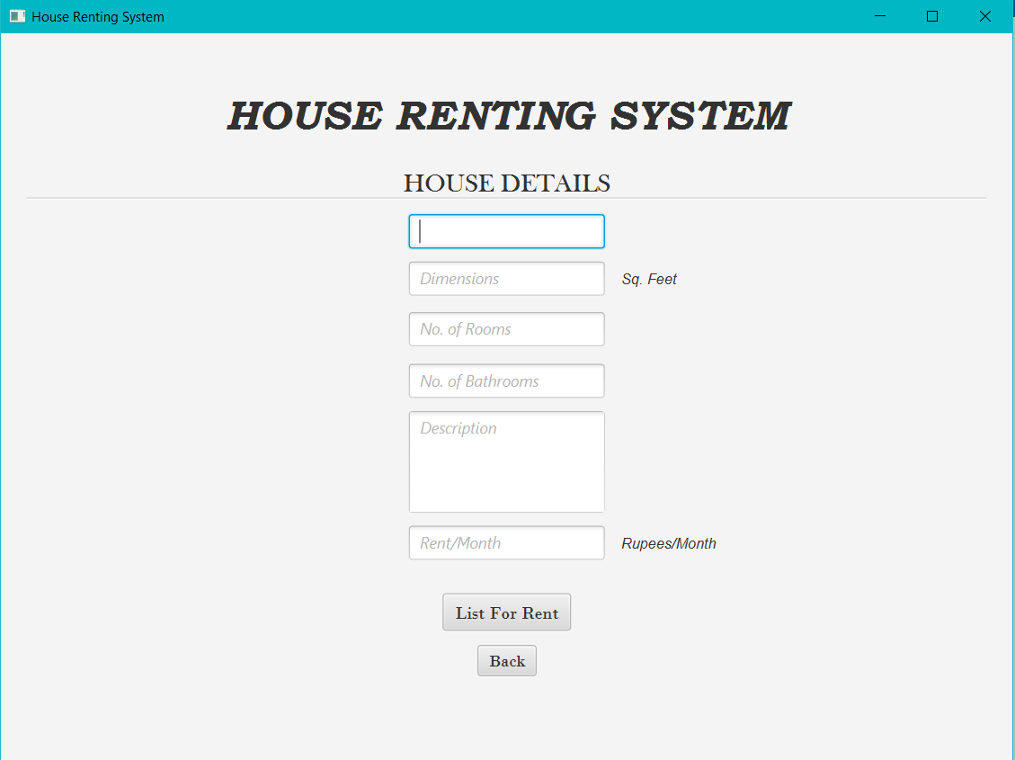
The houses which are yet to be put on rent are marked with status 1.
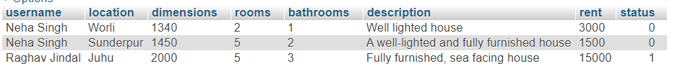
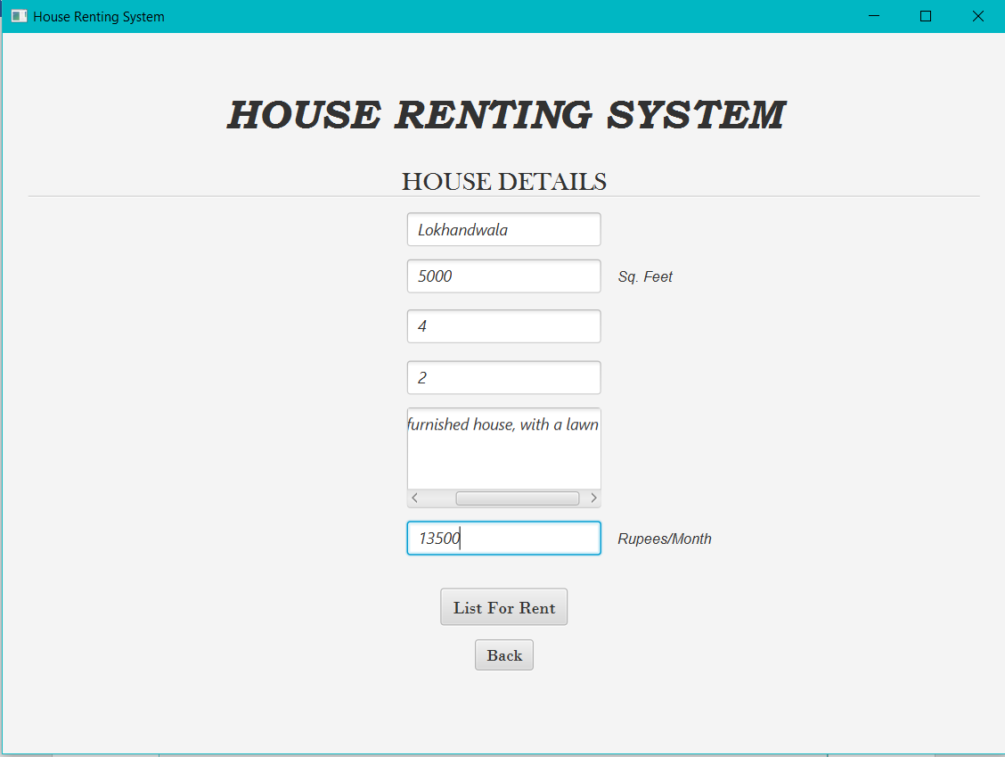
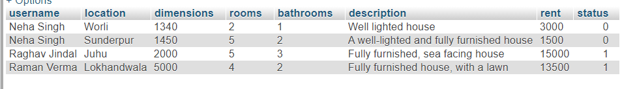

Success to put on Rent:-
Once the house is successfully put on rent, the user will be directed to a page to tell him for his success.
Code:-
Sell_success.fxml==>
<?xml version="1.0" encoding="UTF-8"?>

<?import javafx.scene.control.Button?>
<?import javafx.scene.control.Label?>
<?import javafx.scene.layout.AnchorPane?>
<?import javafx.scene.layout.BorderPane?>
<?import javafx.scene.text.Font?>

<AnchorPane id="AnchorPane" fx:id="sellBackPane" prefHeight="600.0" prefWidth="900.0" xmlns="http://javafx.com/javafx/11.0.1" xmlns:fx="http://javafx.com/fxml/1" fx:controller="Rental.Sell_successController">
<children>
<BorderPane layoutX="9.0" layoutY="14.0" prefHeight="142.0" prefWidth="880.0">
<center>
<Label alignment="CENTER" prefHeight="132.0" prefWidth="866.0" text="HOUSE RENTING SYSTEM" BorderPane.alignment="CENTER">
<font>
<Font name="Bookman Old Style Bold Italic" size="37.0" />
</font>
</Label>
</center>
</BorderPane>
<Label layoutX="265.0" layoutY="201.0" prefHeight="30.0" prefWidth="369.0" text="House is Successfully Listed For Rent" textFill="#f00606">
<font>
<Font name="Arial Italic" size="21.0" />
</font>
</Label>
<Button fx:id="btn1" layoutX="302.0" layoutY="275.0" mnemonicParsing="false" onAction="#goBack" text="Click Here to Go back to the Home Page">
<font>
<Font name="Bodoni MT" size="16.0" />
</font>
</Button>
</children>
</AnchorPane>

Sell_successController.java==>
/*
* To change this license header, choose License Headers in Project Properties.
* To change this template file, choose Tools | Templates
* and open the template in the editor.
*/
package Rental;

import java.io.IOException;
import java.net.URL;
import java.util.ResourceBundle;
import javafx.event.ActionEvent;
import javafx.fxml.FXML;
import javafx.fxml.FXMLLoader;
import javafx.fxml.Initializable;
import javafx.scene.Parent;
import javafx.scene.control.Button;
import javafx.scene.layout.AnchorPane;

/**
* FXML Controller class
*
* @author Swati
*/
public class Sell_successController implements Initializable {

/**
* Initializes the controller class.
*/
@Override
public void initialize(URL url, ResourceBundle rb) {
// TODO
}
@FXML
private Button btn1;
@FXML
private AnchorPane sellBackPane;
String username;
public void getUser(String user){
username = user;
}
public void goBack(ActionEvent event) throws IOException{
FXMLLoader loader = new FXMLLoader();
Parent root1 = loader.load(getClass().getResource("/Rental/MainPage.fxml").openStream());
MainPageController u = (MainPageController)loader.getController();
u.getUser(username);
sellBackPane.getChildren().setAll(root1);
}
}

Interface:-
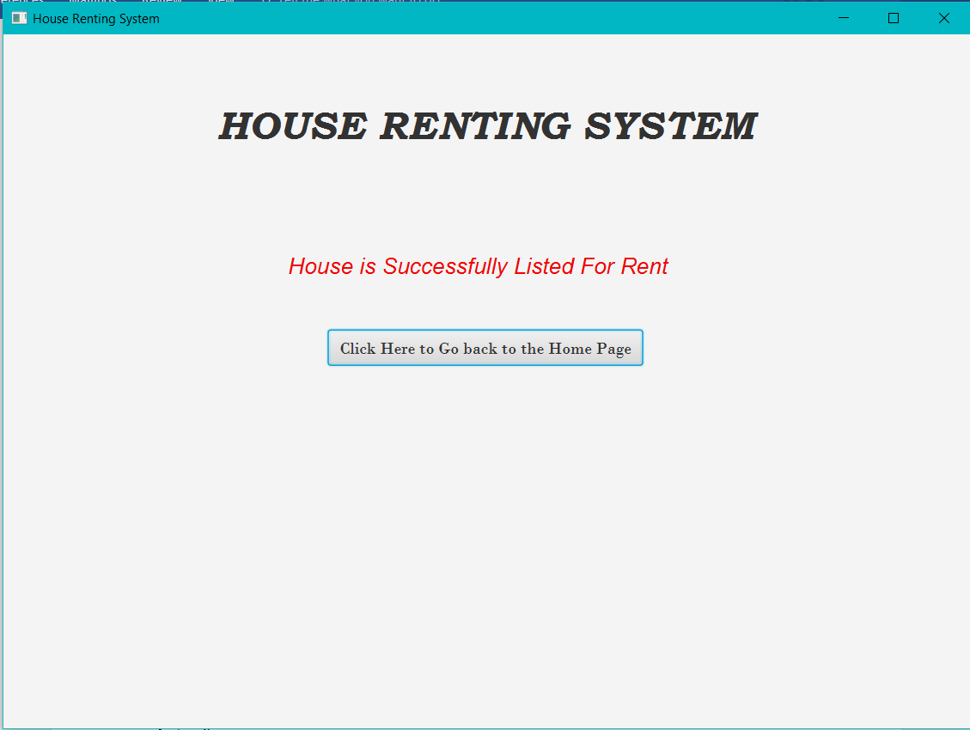

Houses on Rent:-
The user can see the houses on rent and can also verify if his house is put on rent.
Code:-
Houses.java==>
/*
* To change this license header, choose License Headers in Project Properties.
* To change this template file, choose Tools | Templates
* and open the template in the editor.
*/
package Rental;

import javafx.beans.property.SimpleStringProperty;

/**
*
* @author Swati
*/
public class Houses {
private SimpleStringProperty locProperty;
private SimpleStringProperty dimProperty;
private SimpleStringProperty roomProperty;
private SimpleStringProperty bathProperty;
private SimpleStringProperty descProperty;
private SimpleStringProperty rentProperty;
private SimpleStringProperty soldProperty;
public Houses(String a,String b,String c,String d,String e,String f,String g){
this.locProperty = new SimpleStringProperty(a);
this.dimProperty = new SimpleStringProperty(b);
this.roomProperty = new SimpleStringProperty(c);
this.bathProperty = new SimpleStringProperty(d);
this.descProperty = new SimpleStringProperty(e);
this.rentProperty = new SimpleStringProperty(f);
this.soldProperty = new SimpleStringProperty(g);
}

public String getLocProperty() {
return locProperty.get();
}

public void setLocProperty(SimpleStringProperty locProperty) {
this.locProperty = locProperty;
}

public String getDimProperty() {
return dimProperty.get();
}

public void setDimProperty(SimpleStringProperty dimProperty) {
this.dimProperty = dimProperty;
}

public String getRoomProperty() {
return roomProperty.get();
}

public void setRoomProperty(SimpleStringProperty roomProperty) {
this.roomProperty = roomProperty;
}

public String getBathProperty() {
return bathProperty.get();
}

public void setBathProperty(SimpleStringProperty bathProperty) {
this.bathProperty = bathProperty;
}

public String getDescProperty() {
return descProperty.get();
}

public void setDescProperty(SimpleStringProperty descProperty) {
this.descProperty = descProperty;
}

public String getRentProperty() {
return rentProperty.get();
}

public void setRentProperty(SimpleStringProperty rentProperty) {
this.rentProperty = rentProperty;
}

public String getSoldProperty() {
return soldProperty.get();
}

public void setSoldProperty(SimpleStringProperty soldProperty) {
this.soldProperty = soldProperty;
}
}

Purchase.fxml==>
<?xml version="1.0" encoding="UTF-8"?>

<?import javafx.scene.control.Button?>
<?import javafx.scene.control.Label?>
<?import javafx.scene.control.Separator?>
<?import javafx.scene.control.TableColumn?>
<?import javafx.scene.control.TableView?>
<?import javafx.scene.layout.AnchorPane?>
<?import javafx.scene.layout.BorderPane?>
<?import javafx.scene.text.Font?>

<AnchorPane id="AnchorPane" fx:id="buyPane" prefHeight="648.0" prefWidth="900.0" xmlns="http://javafx.com/javafx/11.0.1" xmlns:fx="http://javafx.com/fxml/1" fx:controller="Rental.PurchaseController">
<children>
<BorderPane layoutX="10.0" layoutY="14.0" prefHeight="134.0" prefWidth="880.0">
<center>
<Label alignment="CENTER" prefHeight="116.0" prefWidth="863.0" text="HOUSE RENTING SYSTEM" BorderPane.alignment="CENTER">
<font>
<Font name="Bookman Old Style Bold Italic" size="37.0" />
</font>
</Label>
</center>
</BorderPane>
<Label alignment="CENTER" layoutX="14.0" layoutY="148.0" prefHeight="18.0" prefWidth="880.0" text="Houses on Rent" textFill="#1a4eeb">
<font>
<Font name="Arial Bold Italic" size="21.0" />
</font>
</Label>
<Separator layoutX="23.0" layoutY="175.0" prefHeight="3.0" prefWidth="855.0" />
<Button fx:id="btn1" layoutX="428.0" layoutY="606.0" mnemonicParsing="false" onAction="#back" text="Back">
<font>
<Font name="Bodoni MT" size="15.0" />
</font>
</Button>
<TableView fx:id="table" layoutX="23.0" layoutY="186.0" prefHeight="343.0" prefWidth="855.0">
<columns>
<TableColumn fx:id="locColumn" prefWidth="128.00002479553223" sortable="false" text="House Location" />
<TableColumn fx:id="dimColumn" prefWidth="98.4000244140625" sortable="false" text="Dimension" />
<TableColumn fx:id="roomColumn" prefWidth="72.7999267578125" sortable="false" text="#Rooms" />
<TableColumn fx:id="bathColumn" prefWidth="95.2000732421875" text="#Bathrooms" />
<TableColumn fx:id="descColumn" prefWidth="218.40005493164062" sortable="false" text="Description" />
<TableColumn fx:id="rentColumn" minWidth="0.0" prefWidth="92.800048828125" text="Rent" />
<TableColumn fx:id="soldColumn" prefWidth="148.00006103515625" text="Landlord" />
</columns>
</TableView>
<Button fx:id="rentBtn" layoutX="428.0" layoutY="567.0" mnemonicParsing="false" onAction="#onRent" text="Rent">
<font>
<Font name="Bodoni MT" size="15.0" />
</font>
</Button>
<Label fx:id="lbl1" layoutX="383.0" layoutY="542.0" prefHeight="18.0" prefWidth="142.0" textFill="#f80202">
<font>
<Font name="Bodoni MT Italic" size="14.0" />
</font>
</Label>
</children>
</AnchorPane>

PurchaseController.java==>
/*
* To change this license header, choose License Headers in Project Properties.
* To change this template file, choose Tools | Templates
* and open the template in the editor.
*/
package Rental;

import com.mysql.jdbc.Connection;
import com.mysql.jdbc.PreparedStatement;
import java.io.IOException;
import java.net.URL;
import java.sql.DriverManager;
import java.sql.ResultSet;
import java.sql.SQLException;
import java.util.ResourceBundle;
import java.util.logging.Level;
import java.util.logging.Logger;
import javafx.collections.FXCollections;
import javafx.collections.ObservableList;
import javafx.event.ActionEvent;
import javafx.fxml.FXML;
import javafx.fxml.FXMLLoader;
import javafx.fxml.Initializable;
import javafx.scene.Parent;
import javafx.scene.control.Button;
import javafx.scene.control.Label;
import javafx.scene.control.TableColumn;
import javafx.scene.control.TableView;
import javafx.scene.control.cell.PropertyValueFactory;
import javafx.scene.layout.AnchorPane;

/**
* FXML Controller class
*
* @author Swati
*/
public class PurchaseController implements Initializable {

/**
* Initializes the controller class.
*/
@FXML
private Button btn1;
String username;
@FXML
private AnchorPane buyPane;
@FXML
private TableView<Houses> table;
@FXML
private TableColumn<Houses,String> locColumn;
@FXML
private TableColumn<Houses,String> dimColumn;
@FXML
private TableColumn<Houses,String> roomColumn;
@FXML
private TableColumn<Houses,String> bathColumn;
@FXML
private TableColumn<Houses,String> descColumn;
@FXML
private TableColumn<Houses,String> rentColumn;
@FXML
private TableColumn<Houses,String> soldColumn;
@FXML
private Button rentBtn;
@FXML
private Label lbl1;
Connection conn;
PreparedStatement pst;
PreparedStatement pst1;
ResultSet rs;
@Override
public void initialize(URL url, ResourceBundle rb) {
locColumn.setCellValueFactory(new PropertyValueFactory<>("locProperty"));
dimColumn.setCellValueFactory(new PropertyValueFactory<>("dimProperty"));
roomColumn.setCellValueFactory(new PropertyValueFactory<>("roomProperty"));
bathColumn.setCellValueFactory(new PropertyValueFactory<>("bathProperty"));
descColumn.setCellValueFactory(new PropertyValueFactory<>("descProperty"));
rentColumn.setCellValueFactory(new PropertyValueFactory<>("rentProperty"));
soldColumn.setCellValueFactory(new PropertyValueFactory<>("soldProperty"));
try {
table.setItems(getData());
} catch (SQLException ex) {
Logger.getLogger(PurchaseController.class.getName()).log(Level.SEVERE, null, ex);
}
}
public ObservableList<Houses> getData() throws SQLException{
ObservableList<Houses> h =FXCollections.observableArrayList();
try{
Class.forName("com.mysql.jdbc.Driver");
conn = (Connection) DriverManager.getConnection("jdbc:mysql://localhost:3308/houserentalsystem","root","12345");
pst = (PreparedStatement) conn.prepareStatement("Select * from house_sell where status=?");
pst.setBoolean(1,true);
rs = pst.executeQuery();
while(rs.next()){
h.add(new Houses(rs.getString(2),rs.getString(3),rs.getString(4),rs.getString(5),rs.getString(6),rs.getString(7),rs.getString(1)));

//Stage stage1 = new Stage();
//pst1.setString(2,pass);
/*
rs1 = pst1.executeQuery();
if(rs1.next()){
FXMLLoader loader = new FXMLLoader();
Parent root1 = loader.load(getClass().getResource("/Rental/MainPage.fxml").openStream());
MainPageController u = (MainPageController)loader.getController();
u.getUser(rs1.getString("name"));
LoginPane.getChildren().setAll(root1);
}
*/
}
conn.close();
} catch (ClassNotFoundException ex) {
Logger.getLogger(LoginController.class.getName()).log(Level.SEVERE, null, ex);
}
return h;
}
public void getUser(String user){
username = user;
}
public void onRent(ActionEvent event) throws ClassNotFoundException, SQLException, IOException{
Houses h = table.getSelectionModel().getSelectedItem();
String a = h.getSoldProperty();
String b = h.getDimProperty();
String c = h.getRoomProperty();
String d = h.getBathProperty();
String e = h.getRentProperty();
String f = h.getLocProperty();
String g = h.getDescProperty();
if((h.getSoldProperty()).equals(username)) {
lbl1.setText("You cannot Rent a house sold by you!");
} else {
try{
Class.forName("com.mysql.jdbc.Driver");
conn = (Connection) DriverManager.getConnection("jdbc:mysql://localhost:3308/houserentalsystem","root","12345");
pst = (PreparedStatement) conn.prepareStatement("update house_sell set status=? where username=? and dimensions=? and rooms=? and bathrooms=? and rent=?");
pst.setBoolean(1,false);
pst.setString(2, a);
pst.setString(3,b);
pst.setString(4,c);
pst.setString(5,d);
pst.setString(6,e);
pst.executeUpdate();
pst1 = (PreparedStatement) conn.prepareStatement("Insert into buyer_detail (location,dimension,room,bathroom,description,rent,sold_by,purchase_by)"+"values(?,?,?,?,?,?,?,?)");
pst1.setString(1,f);
pst1.setString(2,b);
pst1.setString(3,c);
pst1.setString(4,d);
pst1.setString(5,g);
pst1.setString(6,e);
pst1.setString(7,a);
pst1.setString(8,username);
pst1.execute();
conn.close();
FXMLLoader loader = new FXMLLoader();
Parent root1 = loader.load(getClass().getResource("/Rental/buy_success.fxml").openStream());
Buy_successController u = (Buy_successController)loader.getController();
u.getUser(username);
buyPane.getChildren().setAll(root1);
}
catch (ClassNotFoundException ex) {
Logger.getLogger(LoginController.class.getName()).log(Level.SEVERE, null, ex);
}
}

}
public void back(ActionEvent event) throws IOException{
FXMLLoader loader = new FXMLLoader();
Parent root1 = loader.load(getClass().getResource("/Rental/MainPage.fxml").openStream());
MainPageController u = (MainPageController)loader.getController();
u.getUser(username);
buyPane.getChildren().setAll(root1);
}
}

Interface:-
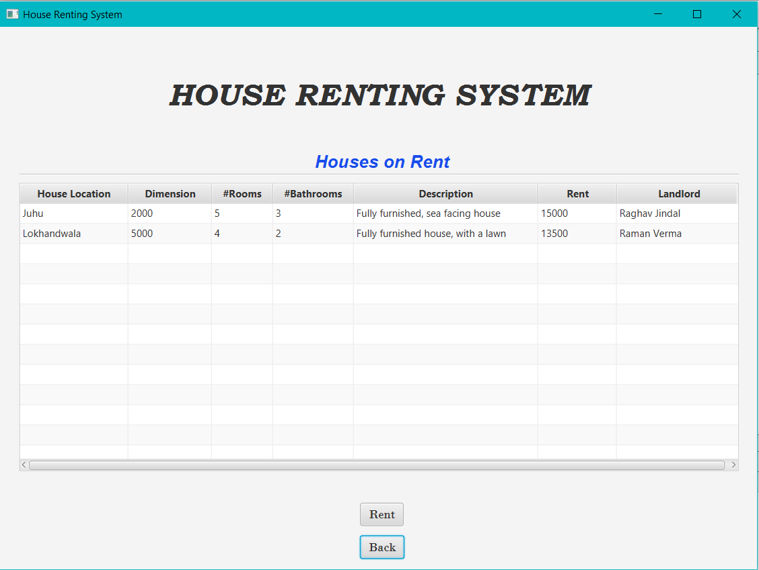

User can select a house to rent. That data will be saved in a new table.
But a user cannot select a house which he himself have put on rent.

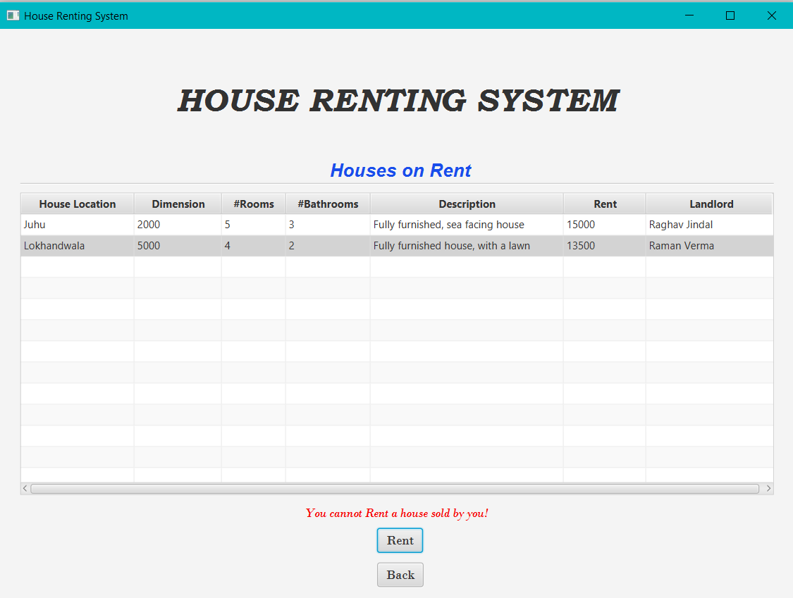
Other than that house, he can take any house and his details will be saved in database.
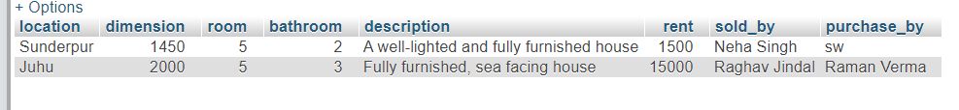

Successful rent of house:-
This page appears after a user take a house for rent.
Code:-
Buy_success.fxml==>
<?xml version="1.0" encoding="UTF-8"?>

<?import javafx.scene.control.Button?>
<?import javafx.scene.control.Label?>
<?import javafx.scene.layout.AnchorPane?>
<?import javafx.scene.layout.BorderPane?>
<?import javafx.scene.text.Font?>

<AnchorPane id="AnchorPane" fx:id="buySuccessPane" prefHeight="600.0" prefWidth="900.0" xmlns="http://javafx.com/javafx/11.0.1" xmlns:fx="http://javafx.com/fxml/1" fx:controller="Rental.Buy_successController">
<children>
<BorderPane layoutX="8.0" layoutY="14.0" prefHeight="124.0" prefWidth="882.0">
<center>
<Label alignment="CENTER" prefHeight="110.0" prefWidth="870.0" text="HOUSE RENTING SYSTEM" BorderPane.alignment="CENTER">
<font>
<Font name="Bookman Old Style Bold Italic" size="37.0" />
</font>
</Label>
</center>
</BorderPane>
<Label layoutX="273.0" layoutY="211.0" prefHeight="36.0" prefWidth="352.0" text="The House is Successfully Rented to you" textFill="#f20404">
<font>
<Font name="Bodoni MT Italic" size="22.0" />
</font>
</Label>
<Button fx:id="btn" layoutX="361.0" layoutY="300.0" mnemonicParsing="false" onAction="#goBack" text="Click here to go Back">
<font>
<Font name="Bodoni MT" size="17.0" />
</font>
</Button>
</children>
</AnchorPane>

Buy_successController.java==>
/*
* To change this license header, choose License Headers in Project Properties.
* To change this template file, choose Tools | Templates
* and open the template in the editor.
*/
package Rental;

import java.io.IOException;
import java.net.URL;
import java.util.ResourceBundle;
import javafx.event.ActionEvent;
import javafx.fxml.FXML;
import javafx.fxml.FXMLLoader;
import javafx.fxml.Initializable;
import javafx.scene.Parent;
import javafx.scene.control.Button;
import javafx.scene.layout.AnchorPane;

/**
* FXML Controller class
*
* @author Swati
*/
public class Buy_successController implements Initializable {

/**
* Initializes the controller class.
*/
@FXML
private Button btn;
@FXML
private AnchorPane buySuccessPane;
String username;
@Override
public void initialize(URL url, ResourceBundle rb) {
// TODO
}
public void getUser(String user){
username = user;
}
public void goBack(ActionEvent event) throws IOException{
FXMLLoader loader = new FXMLLoader();
Parent root1 = loader.load(getClass().getResource("/Rental/MainPage.fxml").openStream());
MainPageController u = (MainPageController)loader.getController();
u.getUser(username);
buySuccessPane.getChildren().setAll(root1);
}
}

Interface:-
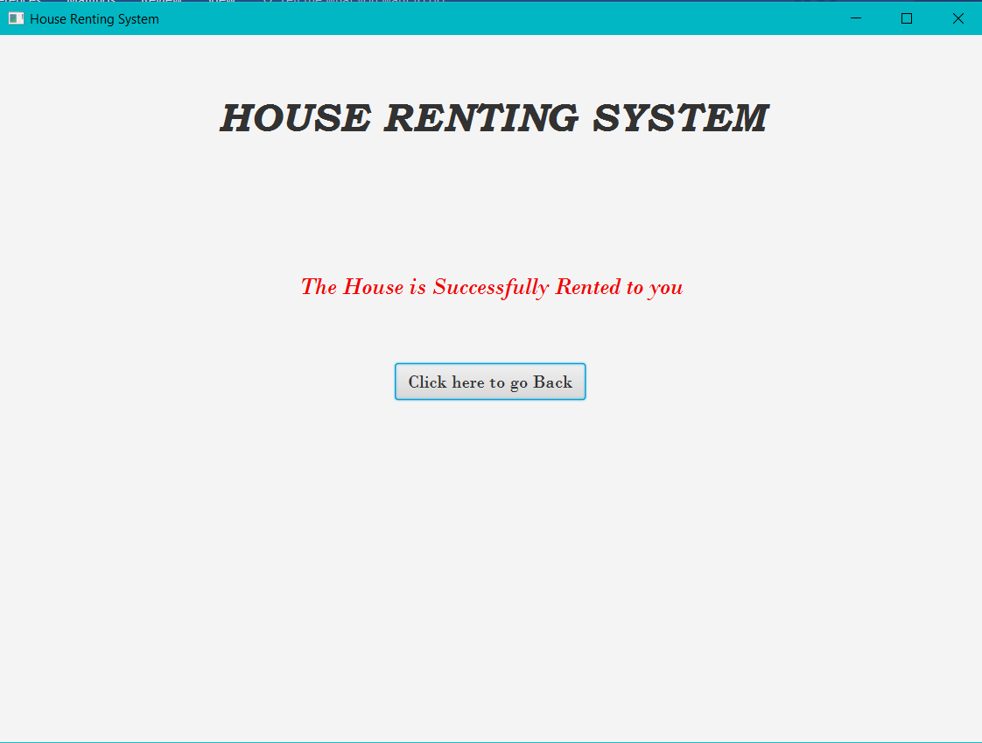

Rented House:-
This feature is used by the landlord to check who has rented their house.
Code:-
House.java file is used here as well.

View.fxml==>
<?xml version="1.0" encoding="UTF-8"?>

<?import javafx.scene.control.Button?>
<?import javafx.scene.control.Label?>
<?import javafx.scene.control.TableColumn?>
<?import javafx.scene.control.TableView?>
<?import javafx.scene.layout.AnchorPane?>
<?import javafx.scene.layout.BorderPane?>
<?import javafx.scene.text.Font?>

<AnchorPane id="AnchorPane" fx:id="viewPane" prefHeight="600.0" prefWidth="900.0" xmlns="http://javafx.com/javafx/11.0.1" xmlns:fx="http://javafx.com/fxml/1" fx:controller="Rental.ViewController">
<children>
<BorderPane layoutX="11.0" layoutY="14.0" prefHeight="118.0" prefWidth="878.0">
<center>
<Label alignment="CENTER" prefHeight="103.0" prefWidth="866.0" text="HOUSE RENTING SYSTEM" BorderPane.alignment="CENTER">
<font>
<Font name="Bookman Old Style Bold Italic" size="37.0" />
</font>
</Label>
</center>
</BorderPane>
<TableView fx:id="viewTable" layoutX="23.0" layoutY="132.0" prefHeight="378.0" prefWidth="854.0">
<columns>
<TableColumn fx:id="loc" prefWidth="111.20000648498535" text="Location" />
<TableColumn fx:id="dim" prefWidth="95.99996948242188" text="Dimension" />
<TableColumn fx:id="room" prefWidth="91.20001220703125" text="Rooms" />
<TableColumn fx:id="bath" prefWidth="103.99993896484375" text="Bathrooms" />
<TableColumn fx:id="desc" prefWidth="191.20004272460938" text="Description" />
<TableColumn fx:id="rent" prefWidth="96.79998779296875" text="Rent" />
<TableColumn fx:id="user_buy" prefWidth="158.4000244140625" text="Rented By" />
</columns>
</TableView>
<Button fx:id="btn1" alignment="CENTER" contentDisplay="CENTER" layoutX="425.0" layoutY="558.0" mnemonicParsing="false" onAction="#back" text="Back">
<font>
<Font name="Bodoni MT" size="14.0" />
</font>
</Button>
<Label fx:id="lbl1" alignment="CENTER" contentDisplay="CENTER" layoutX="253.0" layoutY="529.0" prefHeight="18.0" prefWidth="394.0" textFill="#f20707">
<font>
<Font name="Bodoni MT Italic" size="14.0" />
</font>
</Label>
</children>
</AnchorPane>

ViewController.java==>
/*
* To change this license header, choose License Headers in Project Properties.
* To change this template file, choose Tools | Templates
* and open the template in the editor.
*/
package Rental;

import com.mysql.jdbc.Connection;
import com.mysql.jdbc.PreparedStatement;
import java.io.IOException;
import java.net.URL;
import java.sql.DriverManager;
import java.sql.ResultSet;
import java.sql.SQLException;
import java.util.ResourceBundle;
import java.util.logging.Level;
import java.util.logging.Logger;
import javafx.collections.FXCollections;
import javafx.collections.ObservableList;
import javafx.event.ActionEvent;
import javafx.fxml.FXML;
import javafx.fxml.FXMLLoader;
import javafx.fxml.Initializable;
import javafx.scene.Parent;
import javafx.scene.control.Button;
import javafx.scene.control.Label;
import javafx.scene.control.TableColumn;
import javafx.scene.control.TableView;
import javafx.scene.control.cell.PropertyValueFactory;
import javafx.scene.layout.AnchorPane;

/**
* FXML Controller class
*
* @author Swati
*/
public class ViewController implements Initializable {

/**
* Initializes the controller class.
*/

@FXML
private AnchorPane viewPane;
@FXML
private Button btn1;
private String username;
@FXML
private TableView<Houses> viewTable;
@FXML
private TableColumn<Houses,String> loc;
@FXML
private TableColumn<Houses,String> dim;
@FXML
private TableColumn<Houses,String> room;
@FXML
private TableColumn<Houses,String> bath;
@FXML
private TableColumn<Houses,String> desc;
@FXML
private TableColumn<Houses,String> rent;
@FXML
private TableColumn<Houses,String> user_buy;
@FXML
private Label lbl1;
Connection conn;
PreparedStatement pst;
ResultSet rs;
@Override
public void initialize(URL url, ResourceBundle rb) {
loc.setCellValueFactory(new PropertyValueFactory<>("locProperty"));
dim.setCellValueFactory(new PropertyValueFactory<>("dimProperty"));
room.setCellValueFactory(new PropertyValueFactory<>("roomProperty"));
bath.setCellValueFactory(new PropertyValueFactory<>("bathProperty"));
desc.setCellValueFactory(new PropertyValueFactory<>("descProperty"));
rent.setCellValueFactory(new PropertyValueFactory<>("rentProperty"));
user_buy.setCellValueFactory(new PropertyValueFactory<>("soldProperty"));
try {
viewTable.setItems(getData());
} catch (SQLException ex) {
Logger.getLogger(PurchaseController.class.getName()).log(Level.SEVERE, null, ex);
}
}
public ObservableList<Houses> getData() throws SQLException{
ObservableList<Houses> h =FXCollections.observableArrayList();
try{
Class.forName("com.mysql.jdbc.Driver");
conn = (Connection) DriverManager.getConnection("jdbc:mysql://localhost:3308/houserentalsystem","root","12345");
pst = (PreparedStatement) conn.prepareStatement("Select * from buyer_detail where sold_by=?");
pst.setString(1,username);
rs = pst.executeQuery();
if(rs.next()){
h.add(new Houses(rs.getString(1),rs.getString(2),rs.getString(3),rs.getString(4),rs.getString(5),rs.getString(6),rs.getString(8)));
}
else{
lbl1.setText("You have not Put any house on Rent"+username);
}
conn.close();
} catch (ClassNotFoundException ex) {
Logger.getLogger(LoginController.class.getName()).log(Level.SEVERE, null, ex);
}
return h;
}
public void getUser(String user){
username = user;
//lbl1.setText(username);
}
public void back(ActionEvent event) throws IOException{
FXMLLoader loader = new FXMLLoader();
Parent root1 = loader.load(getClass().getResource("/Rental/MainPage.fxml").openStream());
MainPageController u = (MainPageController)loader.getController();
u.getUser(username);
viewPane.getChildren().setAll(root1);
}

}

Interface:-
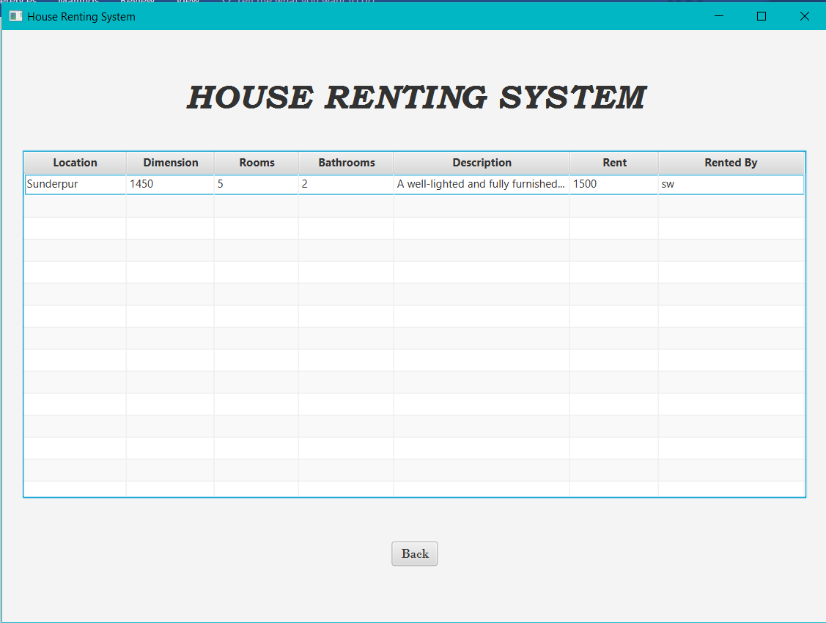
If a User has not put any house on rent, or his house is not rented yet, then that will also be displayed.
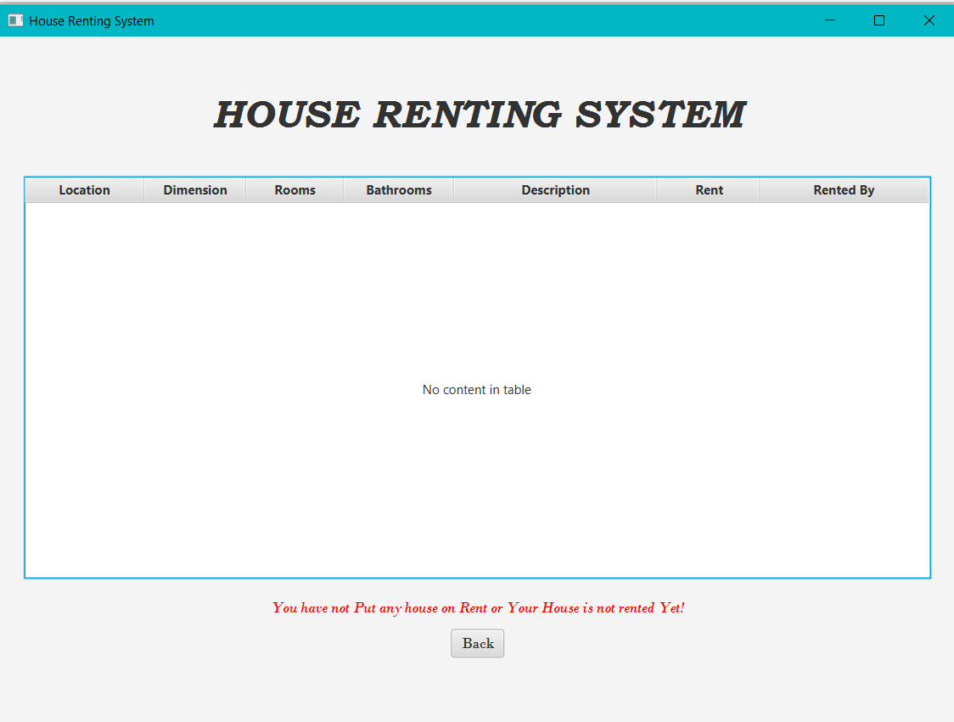

My Profile:-
A user can see the profile details he submitted during registration.
Code:-
MyProfile.fxml==>
<?xml version="1.0" encoding="UTF-8"?>

<?import javafx.scene.control.Button?>
<?import javafx.scene.control.Label?>
<?import javafx.scene.control.Separator?>
<?import javafx.scene.layout.AnchorPane?>
<?import javafx.scene.layout.BorderPane?>
<?import javafx.scene.text.Font?>

<AnchorPane id="AnchorPane" fx:id="profilePane" prefHeight="600.0" prefWidth="900.0" xmlns="http://javafx.com/javafx/11.0.1" xmlns:fx="http://javafx.com/fxml/1" fx:controller="Rental.MyProfileController">
<children>
<BorderPane layoutX="11.0" layoutY="14.0" prefHeight="142.0" prefWidth="879.0">
<center>
<Label alignment="CENTER" prefHeight="129.0" prefWidth="866.0" text="HOUSE RENTING SYSTEM" BorderPane.alignment="CENTER">
<font>
<Font name="Bookman Old Style Bold Italic" size="37.0" />
</font>
</Label>
</center>
</BorderPane>
<Label layoutX="398.0" layoutY="156.0" text="My Profile">
<font>
<Font name="Bodoni MT" size="23.0" />
</font>
</Label>
<Separator layoutX="349.0" layoutY="184.0" prefWidth="200.0" />
<Label layoutX="151.0" layoutY="213.0" text="Name:">
<font>
<Font name="Arial Bold" size="17.0" />
</font>
</Label>
<Label fx:id="lbl1" layoutX="215.0" layoutY="213.0" prefHeight="20.0" prefWidth="226.0">
<font>
<Font name="Arial Italic" size="17.0" />
</font>
</Label>
<Label layoutX="525.0" layoutY="215.0" text="Date Of Birth:">
<font>
<Font name="Arial Bold" size="17.0" />
</font>
</Label>
<Label fx:id="lbl2" layoutX="645.0" layoutY="215.0" prefHeight="18.0" prefWidth="200.0">
<font>
<Font name="Arial Italic" size="17.0" />
</font>
</Label>
<Label layoutX="151.0" layoutY="274.0" text="Email:">
<font>
<Font name="Arial Bold" size="17.0" />
</font>
</Label>
<Label fx:id="lbl3" layoutX="215.0" layoutY="278.0" prefHeight="18.0" prefWidth="226.0">
<font>
<Font name="Arial Italic" size="17.0" />
</font>
</Label>
<Label layoutX="525.0" layoutY="274.0" text="Phone No.:">
<font>
<Font name="Arial Bold" size="17.0" />
</font>
</Label>
<Label fx:id="lbl4" layoutX="636.0" layoutY="274.0" prefHeight="18.0" prefWidth="200.0">
<font>
<Font name="Arial Italic" size="17.0" />
</font>
</Label>
<Label layoutX="151.0" layoutY="323.0" text="Address:">
<font>
<Font name="Arial Bold" size="17.0" />
</font>
</Label>
<Label fx:id="lbl5" alignment="TOP_LEFT" layoutX="237.0" layoutY="323.0" prefHeight="112.0" prefWidth="600.0">
<font>
<Font name="Arial Italic" size="17.0" />
</font>
</Label>
<Label layoutX="151.0" layoutY="458.0" text="Aadhar No.:">
<font>
<Font name="Arial Bold" size="17.0" />
</font>
</Label>
<Label fx:id="lbl6" layoutX="260.0" layoutY="460.0" prefHeight="18.0" prefWidth="158.0">
<font>
<Font name="Arial Italic" size="17.0" />
</font>
</Label>
<Label layoutX="525.0" layoutY="459.0" text="Pan No.:">
<font>
<Font name="Arial Bold" size="17.0" />
</font>
</Label>
<Label fx:id="lbl7" layoutX="609.0" layoutY="460.0" prefHeight="18.0" prefWidth="200.0">
<font>
<Font name="Arial Italic" size="17.0" />
</font>
</Label>
<Label layoutX="151.0" layoutY="491.0" text="Password:">
<font>
<Font name="Arial Bold" size="17.0" />
</font>
</Label>
<Label fx:id="lbl8" layoutX="260.0" layoutY="491.0" prefHeight="20.0" prefWidth="217.0">
<font>
<Font name="Arial Italic" size="17.0" />
</font>
</Label>
<Button fx:id="btn1" layoutX="419.0" layoutY="541.0" mnemonicParsing="false" onAction="#goBack" text="Back">
<font>
<Font name="Bodoni MT Italic" size="18.0" />
</font>
</Button>
</children>
</AnchorPane>

MyProfileController.java==>
/*
* To change this license header, choose License Headers in Project Properties.
* To change this template file, choose Tools | Templates
* and open the template in the editor.
*/
package Rental;

import com.mysql.jdbc.Connection;
import com.mysql.jdbc.PreparedStatement;
import java.io.IOException;
import java.net.URL;
import java.sql.DriverManager;
import java.sql.ResultSet;
import java.sql.SQLException;
import java.util.ResourceBundle;
import java.util.logging.Level;
import java.util.logging.Logger;
import javafx.event.ActionEvent;
import javafx.fxml.FXML;
import javafx.fxml.FXMLLoader;
import javafx.fxml.Initializable;
import javafx.scene.Parent;
import javafx.scene.control.Button;
import javafx.scene.control.Label;
import javafx.scene.layout.AnchorPane;

/**
* FXML Controller class
*
* @author Swati
*/
public class MyProfileController implements Initializable {

/**
* Initializes the controller class.
*/
@FXML
private Label lbl1;
@FXML
private Label lbl2;
@FXML
private Label lbl3;
@FXML
private Label lbl4;
@FXML
private Label lbl5;
@FXML
private Label lbl6;
@FXML
private Label lbl7;
@FXML
private Label lbl8;
@FXML
private Button btn1;
@FXML
private AnchorPane profilePane;
Connection conn;
PreparedStatement pst;
ResultSet rs;
String username;
@Override
public void initialize(URL url, ResourceBundle rb) {
// TODO
}
public void MyProfileController(String user) throws SQLException{
username = user;
try{
Class.forName("com.mysql.jdbc.Driver");
conn = (Connection) DriverManager.getConnection("jdbc:mysql://localhost:3308/houserentalsystem","root","12345");
pst = (PreparedStatement) conn.prepareStatement("Select * from register where name=?");
pst.setString(1,username);

rs = pst.executeQuery();
if(rs.next()){
lbl1.setText(rs.getString(1));
lbl2.setText(rs.getString(2));
lbl3.setText(rs.getString(3));
lbl4.setText(rs.getString(4));
lbl5.setText(rs.getString(5)+","+rs.getString(6)+","+rs.getString(7)+","+rs.getString(8)+","+rs.getString(9)+","+rs.getString(10));
lbl6.setText(rs.getString(11));
lbl7.setText(rs.getString(12));
lbl8.setText(rs.getString(13));
//Stage stage1 = new Stage();
//pst1.setString(2,pass);
/*
rs1 = pst1.executeQuery();
if(rs1.next()){
FXMLLoader loader = new FXMLLoader();
Parent root1 = loader.load(getClass().getResource("/Rental/MainPage.fxml").openStream());
MainPageController u = (MainPageController)loader.getController();
u.getUser(rs1.getString("name"));
LoginPane.getChildren().setAll(root1);
}
*/
}
} catch (ClassNotFoundException ex) {
Logger.getLogger(LoginController.class.getName()).log(Level.SEVERE, null, ex);
}
}
/*
public void getUser(String user){
username = user;
}
*/
public void goBack(ActionEvent event) throws IOException{
FXMLLoader loader = new FXMLLoader();
Parent root1 = loader.load(getClass().getResource("/Rental/MainPage.fxml").openStream());
MainPageController u = (MainPageController)loader.getController();
u.getUser(username);
profilePane.getChildren().setAll(root1);
}
}

Interface:-
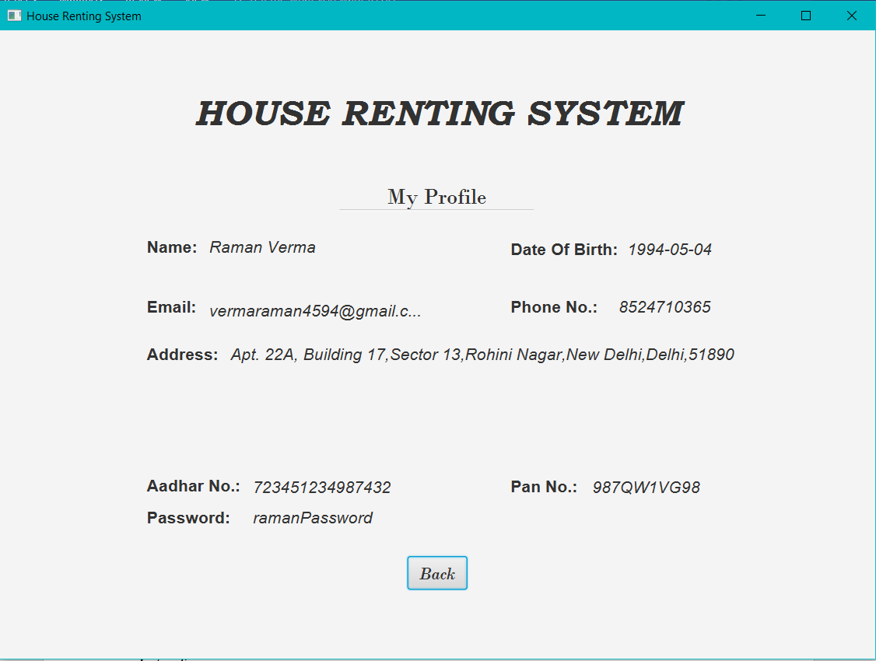

Signout page:-
On selecting the signout button, the person will be signed out and redirected to login page.
Code:-
SignOut.fxml==>
<?xml version="1.0" encoding="UTF-8"?>

<?import javafx.scene.control.Button?>
<?import javafx.scene.control.Label?>
<?import javafx.scene.layout.AnchorPane?>
<?import javafx.scene.layout.BorderPane?>
<?import javafx.scene.text.Font?>

<AnchorPane id="AnchorPane" fx:id="signPane" prefHeight="600.0" prefWidth="900.0" xmlns="http://javafx.com/javafx/11.0.1" xmlns:fx="http://javafx.com/fxml/1" fx:controller="Rental.SignOutController">
<children>
<BorderPane layoutX="10.0" layoutY="14.0" prefHeight="132.0" prefWidth="878.0">
<center>
<Label alignment="CENTER" prefHeight="115.0" prefWidth="863.0" text="HOUSE RENTING SYSTEM" BorderPane.alignment="CENTER">
<font>
<Font name="Bookman Old Style Bold Italic" size="37.0" />
</font>
</Label>
</center>
</BorderPane>
<Label alignment="CENTER" layoutX="321.0" layoutY="219.0" prefHeight="34.0" prefWidth="258.0" text="You are Signed Out" textFill="#f00c0c">
<font>
<Font name="Arial Italic" size="18.0" />
</font>
</Label>
<Button fx:id="btn1" layoutX="348.0" layoutY="283.0" mnemonicParsing="false" onAction="#loginAgain" text="Click Here to Login Again">
<font>
<Font name="Bodoni MT Italic" size="17.0" />
</font>
</Button>
</children>
</AnchorPane>

SignOutController.java==>
/*
* To change this license header, choose License Headers in Project Properties.
* To change this template file, choose Tools | Templates
* and open the template in the editor.
*/
package Rental;

import java.io.IOException;
import java.net.URL;
import java.util.ResourceBundle;
import javafx.event.ActionEvent;
import javafx.fxml.FXML;
import javafx.fxml.FXMLLoader;
import javafx.fxml.Initializable;
import javafx.scene.Parent;
import javafx.scene.control.Button;
import javafx.scene.layout.AnchorPane;

/**
* FXML Controller class
*
* @author Swati
*/
public class SignOutController implements Initializable {

/**
* Initializes the controller class.
*/
@FXML
private Button btn1;
@FXML
private AnchorPane signPane;
@Override
public void initialize(URL url, ResourceBundle rb) {
// TODO
}
public void loginAgain(ActionEvent event) throws IOException{
Parent root = FXMLLoader.load(getClass().getResource("/Rental/Login.fxml"));
signPane.getChildren().setAll(root);
}
}

Interface:-
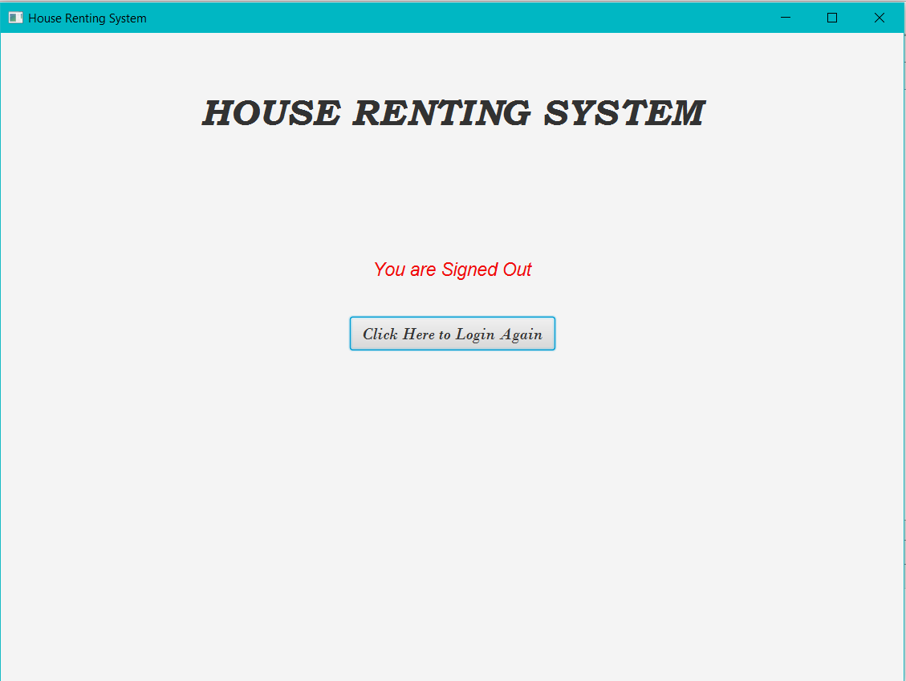

The Main Method:-
Code:-
/*
* To change this license header, choose License Headers in Project Properties.
* To change this template file, choose Tools | Templates
* and open the template in the editor.
*/
package Rental;

import javafx.application.Application;
import static javafx.application.Application.launch;
import javafx.fxml.FXMLLoader;
import javafx.scene.Parent;
import javafx.scene.Scene;
import javafx.stage.Stage;

/**
*
* @author Swati
*/
public class LoginMain extends Application{

@Override
public void start(Stage stage) throws Exception {
Parent root = FXMLLoader.load(getClass().getResource("/Rental/Login.fxml"));
Scene scene = new Scene(root);
stage.setScene(scene);
stage.setTitle("House Renting System");
stage.show();
}
public static void main(String[] args){
launch(args);
}
}

